Setup:

1. Install the Postman plugin.
2. Import the collection “Soum Product Collection.postman_collection.json”
3. Click on the run collection button.

# About Collection:

1. The collection contains two requests:
   1. **Get Product** – This gets the list of the products.
   2. **Ask Seller About Product** – This posts a question to a seller about a product.

## Collection Variables:

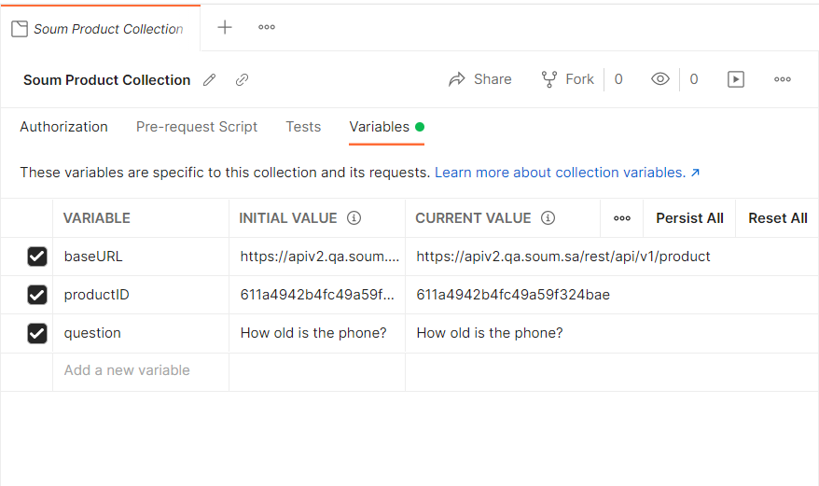

## Tests Covered in “Get Product” Requests.

The following tests are covered in the “Get Product” request.

1. Status code is 200
2. Body contains product id
3. Response contains _id and is not null
4. Response time is less than 400ms
5. The message should contain a success message
6. Verify the endpoint does not return unexpected status codes

## Test Results:

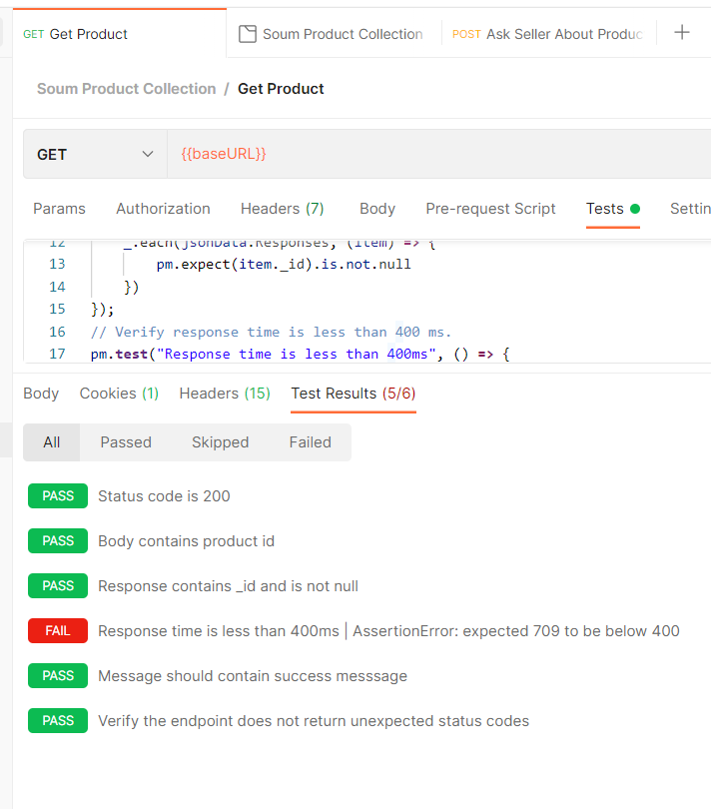

## Tests Covered in “Ask Seller About Product” Requests.

The following tests are covered in the “Ask Seller About Product” request.

1. Status code is 200
2. Response time is less than 400ms
3. Verify the endpoint does not return unexpected status codes
4. Content-Type header is present
5. Body contains _id
6. Body contains _id and _id is not null
7. Body contains product_id
8. Body contains product_id and product_id is not null
9. Body contains questioner_id and questioner_id is not null
10. Body contains created_date and created_date is not null
11. Response body should contain success status

## Test Results:

